

# 

COMPLAINT : 8

DATE: 09/Mar/2021

The Manager,

BKL

sample Branch,sample Zone

Subject: Quotation of Repair and Maintenance. FOR APPROVAL

Number of AC: 1

|  |  |  |  |  |
| --- | --- | --- | --- | --- |
| Sr. | Job Description | Qty | Rate | Amount |
|  | PCB kit Repair with aeroflex installation outdoor | 45 | 2000 | 20000 |
|  | Gas charging | 45 | 2000 | 23445.78 |
|  | Total |  |  | 43445.78 |
|  | Tax 16% |  |  | 6951.3248 |
|  | Visit Charges | 12 | 780 | 9360 |
|  | Total |  |  | 59757.1048 |

**Yours truly,**

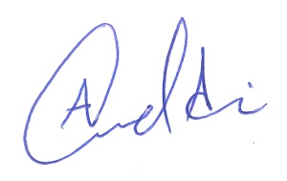 **ECO ENTERPRISES**